## Darshan Nikam Date: 13/04/2024

**Three-Tier Application Deploy From Docker File**

1. Launch Ubuntu Image Based Ec2 Instance.
2. Allow SSH and ports 80, 8080, and 3306.
3. SSH to the Ec2 Instance and run the following commands:

* sudo -i
* apt update -y
* apt install -y docker.io
* systemctl docker status
* cd /opt
* mkdir project
* cd project
* mkdir database fronted proxy_pass
* ls

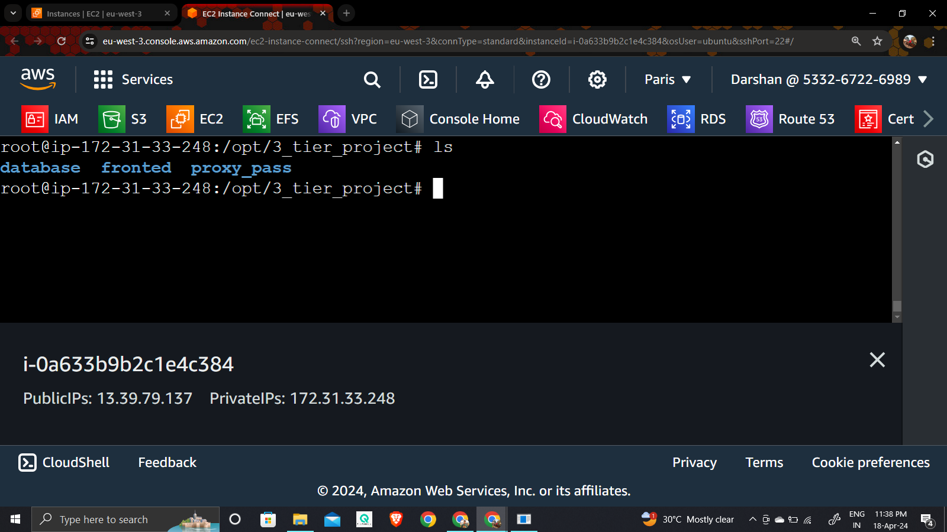

* cd database
* vim Dockerfile

Add the following script in the Dockerfile and save it

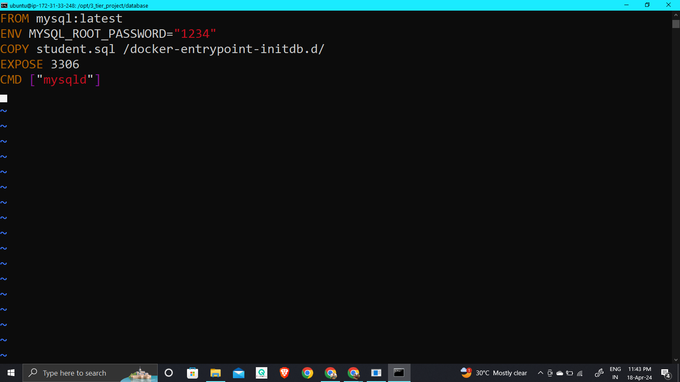

* vim student.sql

Add the following script and save the file

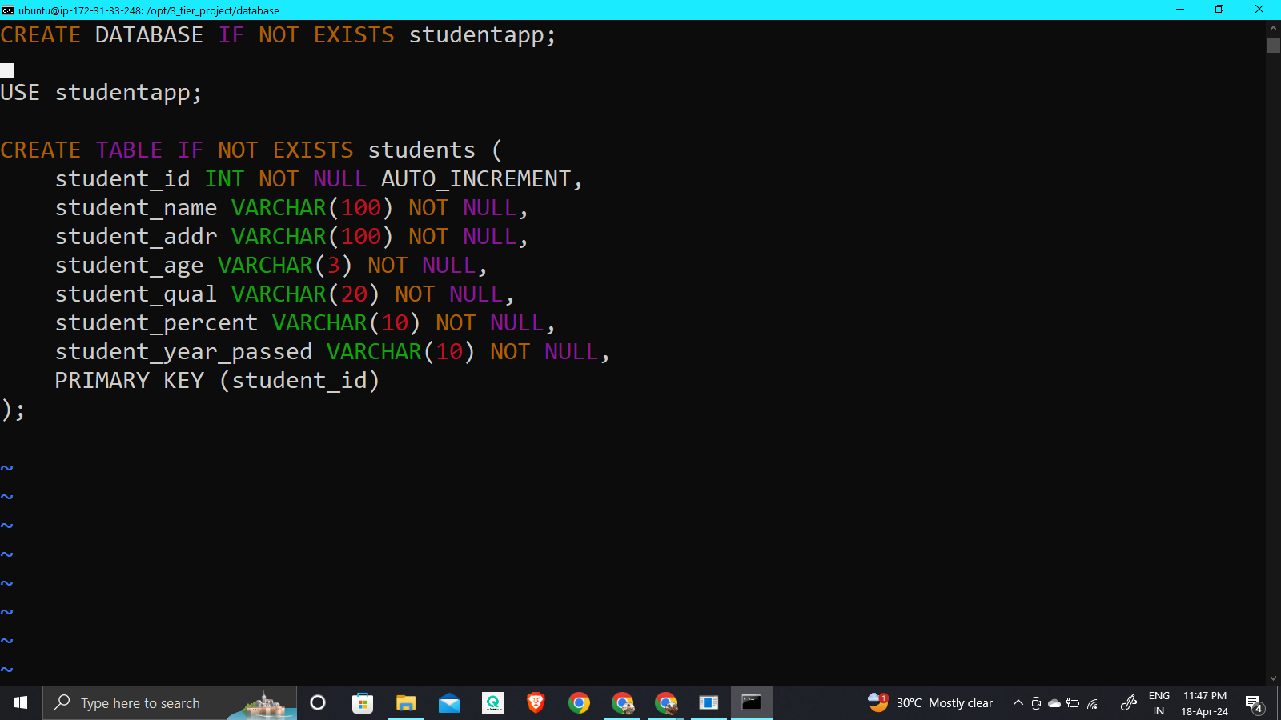

* docker build -t database**.**

( run this command in the database directory where Dockerfile and student.sql files are present)

A Docker Image with a tag database is created. To check the image run the command 🡪 docker images

* Run the following command to create a docker container from the recently created database image.
* docker run -d --name data_server -p 3306:3306 database
* Run the command 🡪 docker ps 🡪 to check running container or 🡪 docker ps -a 🡪 to all container

Now run the following commands to verify within the database container MySQL database and table is created according to over docker file Instruction.

* sudo docker exec -it <container_id> mysql -u root -p1234 -e "use studentapp; desc students;"

( replace user root, password, database name, and table name as you specified in your Dockerfile )

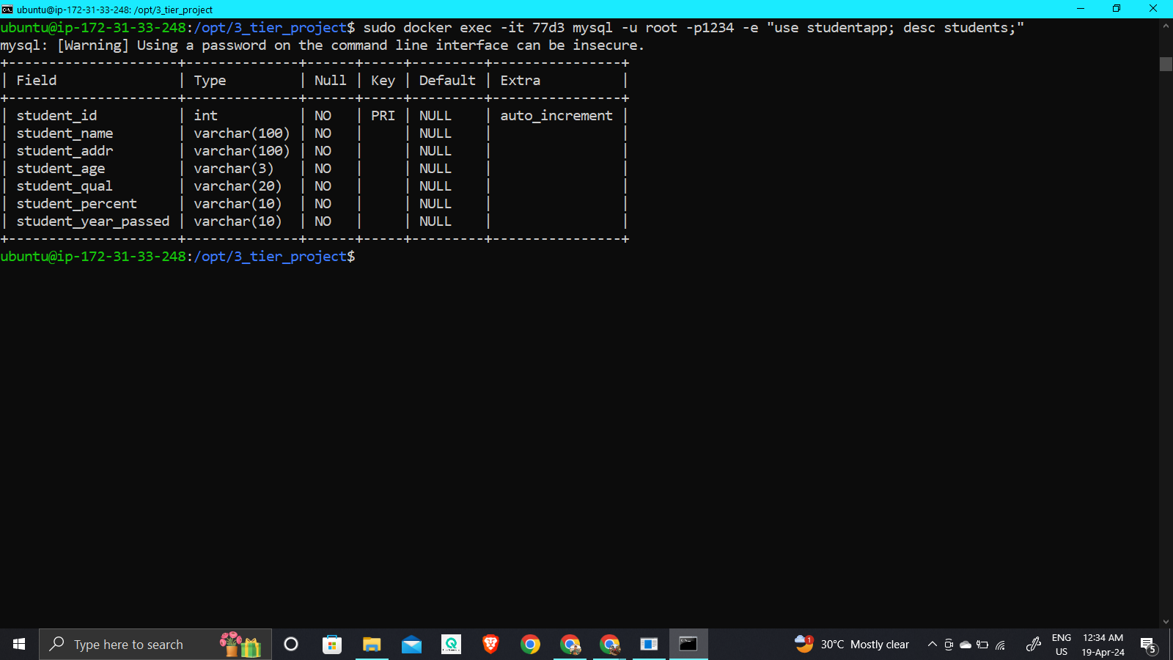

Here can see Database container is correctly created

1. Now we create a Dockerfile for our application.

Run the following commands:

* cd /opt/fronted
* vim Dockerfile

Add the following script in the Dockerfile and save it.

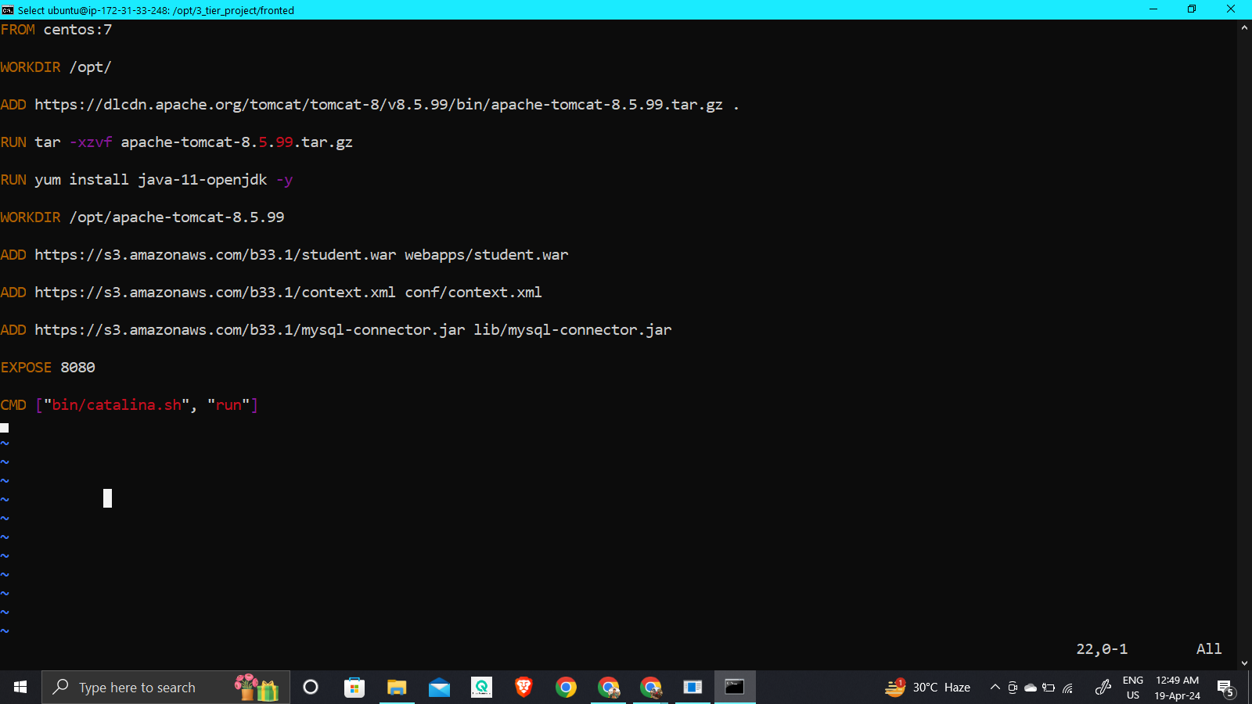

* docker build -t fronted-img .
* docker images

A docker image has been created. now run the following command to create a Container from this image.

* docker run -d --name fronted_server -p 8080:8080 fronted-img

Container has been created. To verify the container is running run the command 🡪 docker ps

1. Now test accessing your application or service running inside the container by navigating to

http://<Ec2-Instance-public-IP>:8080/studentapp in your web browser